PRACTICAL-01
AIM:
Implementation and Time analysis of sorting algorithms. Bubble sort, Selection sort, Insertion sort, Merge sort and Quicksort.
BUBBLE SORT:
ALGORITHM:

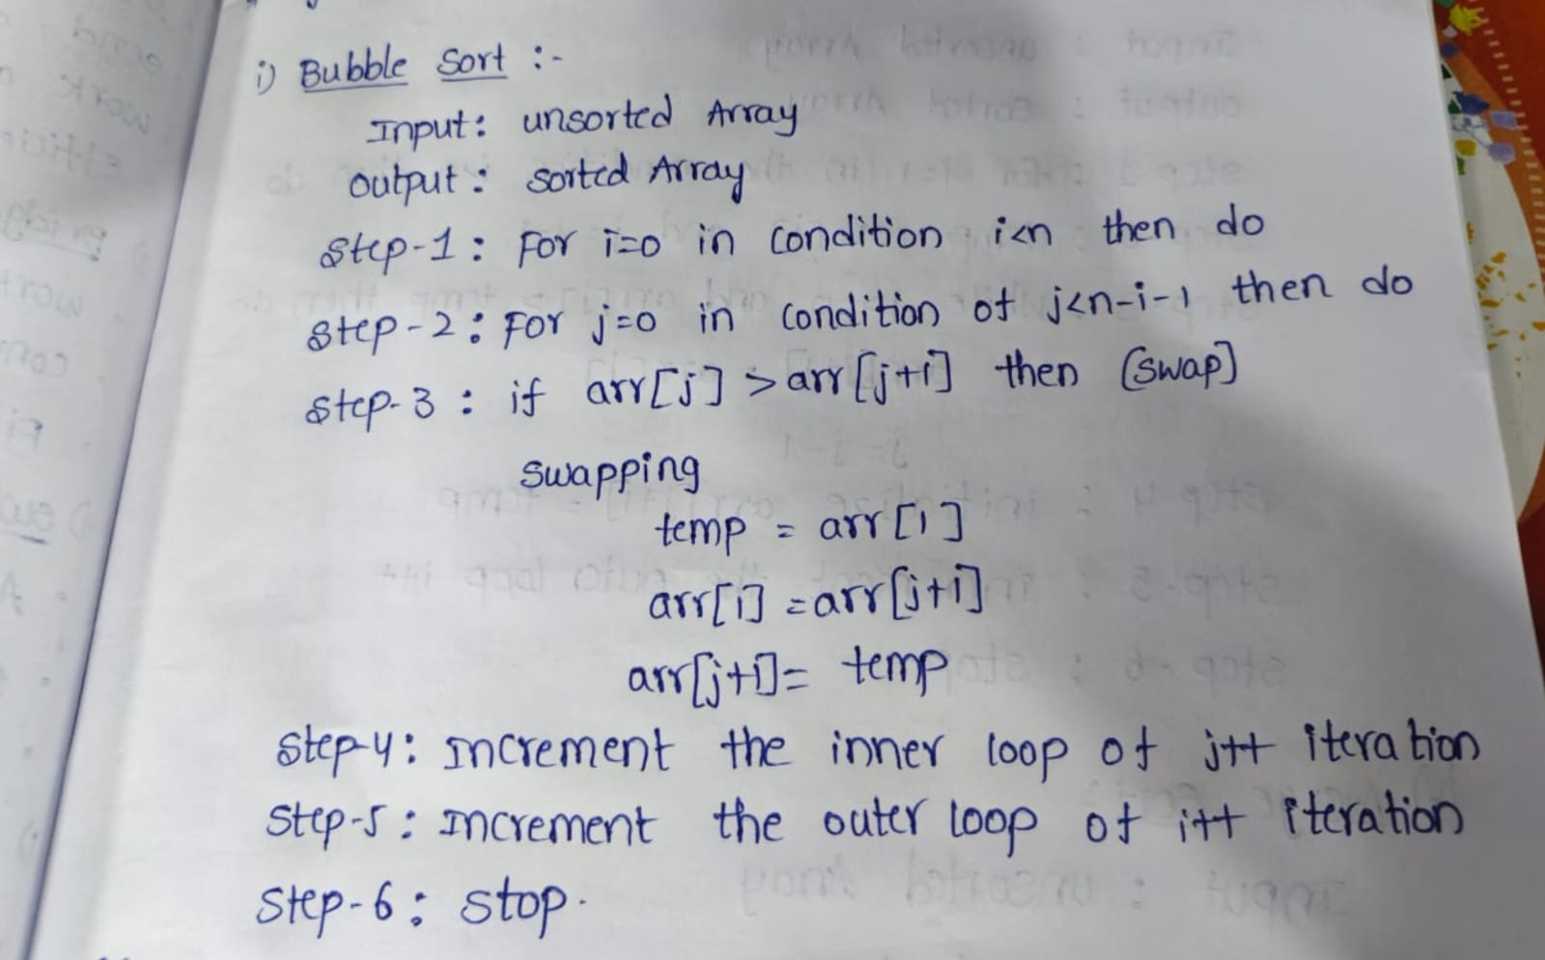

CODE:
#include <iostream>
using namespace std;
class bubblesort
{
public:
int size, arr[100], i;
void arrayinput()
{
cout << "Enter array size: ";
cin >> size;
cout << "Enter array elements:\n";
for (i = 0; i < size; i++)
{
cin >> arr[i];
}
}
void printarray()
{
for (i = 0; i < size; i++)
{
cout << arr[i] << " ";
}
cout << endl;
}
void bubblelogic()
{
int j, temp;
for (i = 0; i < size - 1; i++)
{
for (j = 0; j < size - i - 1; j++)
{
if (arr[j] > arr[j + 1])
{
temp = arr[j];
arr[j] = arr[j + 1];
arr[j + 1] = temp;
}
}
}
}
};
int main()
{
bubblesort bs;
bs.arrayinput();
cout << "Before sorting: ";
bs.printarray();
bs.bubblelogic();
cout << "After sorting: ";
bs.printarray();
return 0;
}

OUTPUT:

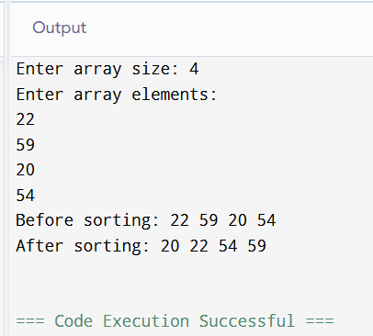

TIME COMPLEXITY:
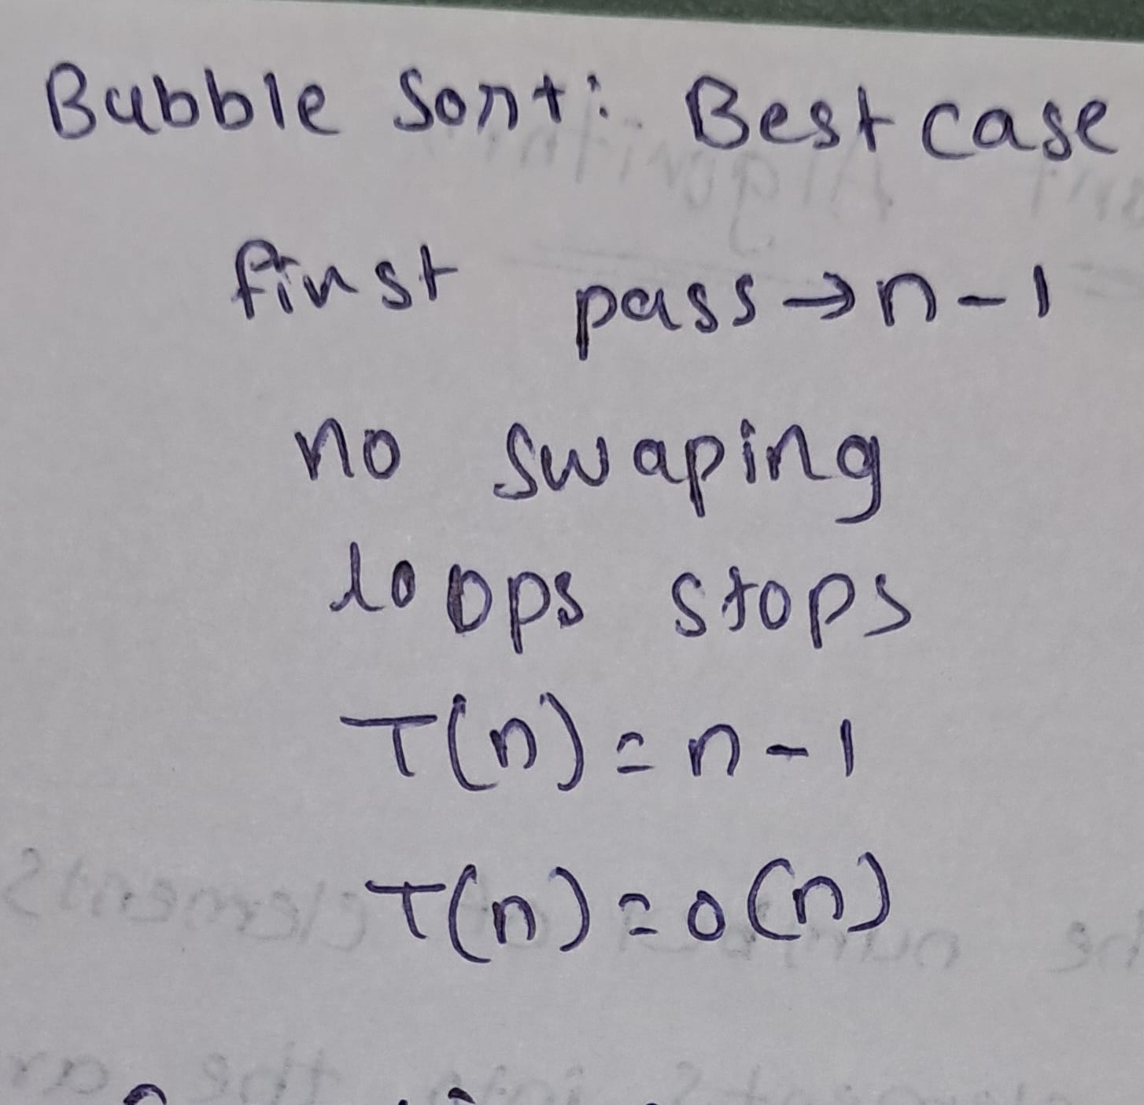
average case:
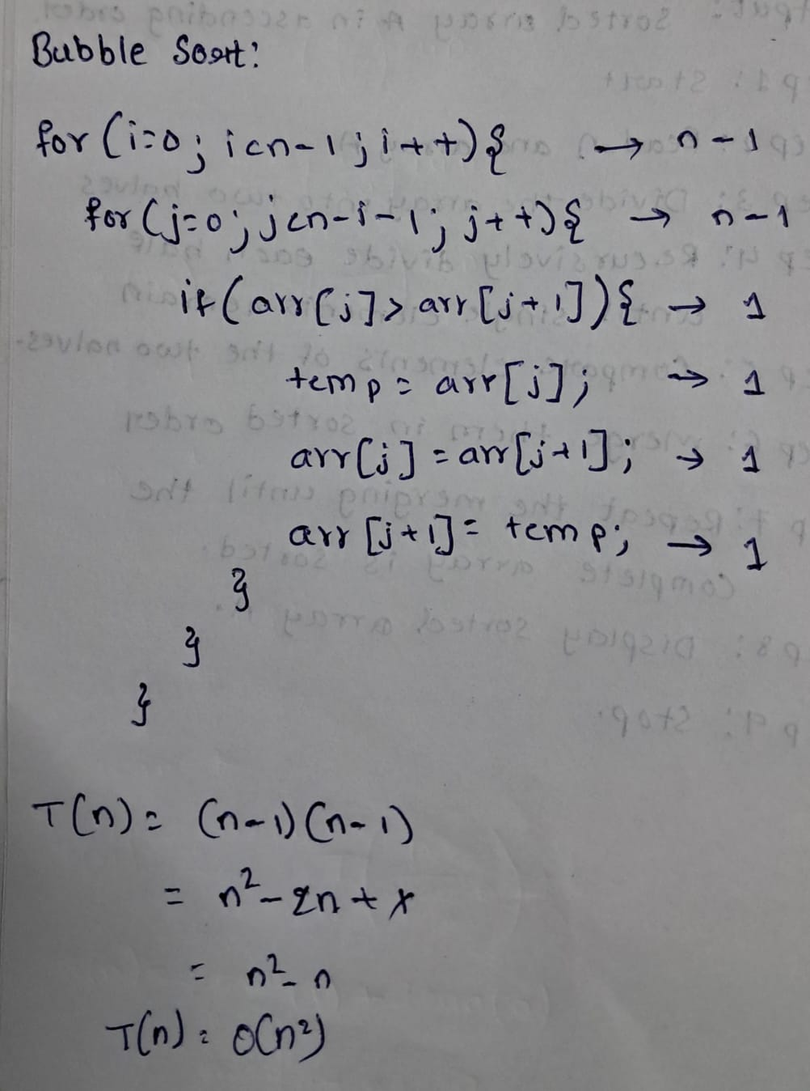
worst case:
if array is in reverse order it takes many comparisons and swaps

INSERTION SORT:
ALGORITHM:
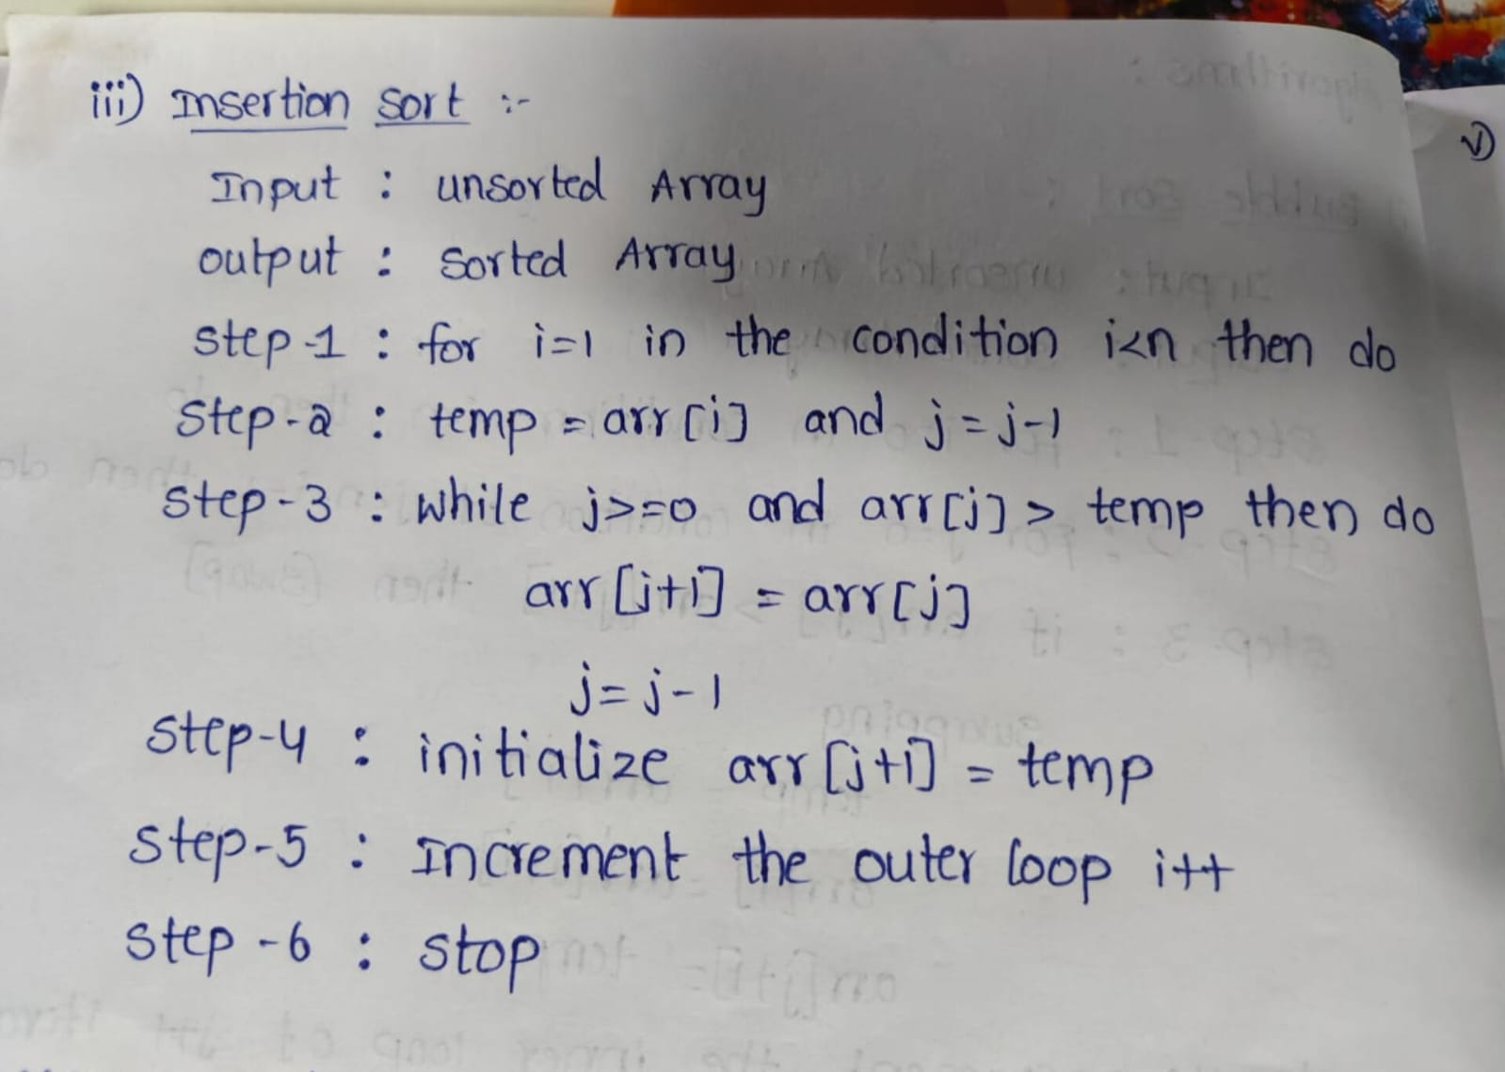

CODE:
#include <iostream>
using namespace std;

class InsertionSort
{
public:
int size, arr[100], i, j, temp;

void arrayinput()
{
cout << "Enter array size: ";
cin >> size;

cout << "Enter array elements: ";
for (i = 0; i < size; i++)
{
cin >> arr[i];
}
}

void printarray()
{
for (i = 0; i < size; i++)
{
cout << arr[i] << " ";
}
cout << endl;
}

void insertionsortlogic()
{
for (i = 1; i < size; i++)
{
temp = arr[i];
j = i - 1;

while (j >= 0 && arr[j] > temp)
{
arr[j + 1] = arr[j];
j--;
}

arr[j + 1] = temp;
}
}
};

int main()
{
InsertionSort is;

is.arrayinput();

cout << "Before sorting: ";
is.printarray();

is.insertionsortlogic();

cout << "After sorting: ";
is.printarray();
return 0;
}

OUTPUT:
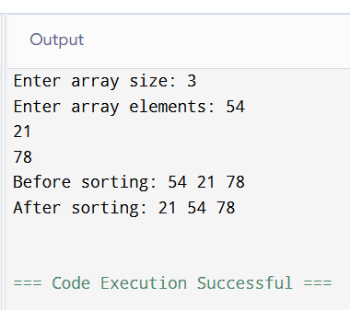
TIME COMPLEXITY:
best case:
if array is sorted we need only one comparision
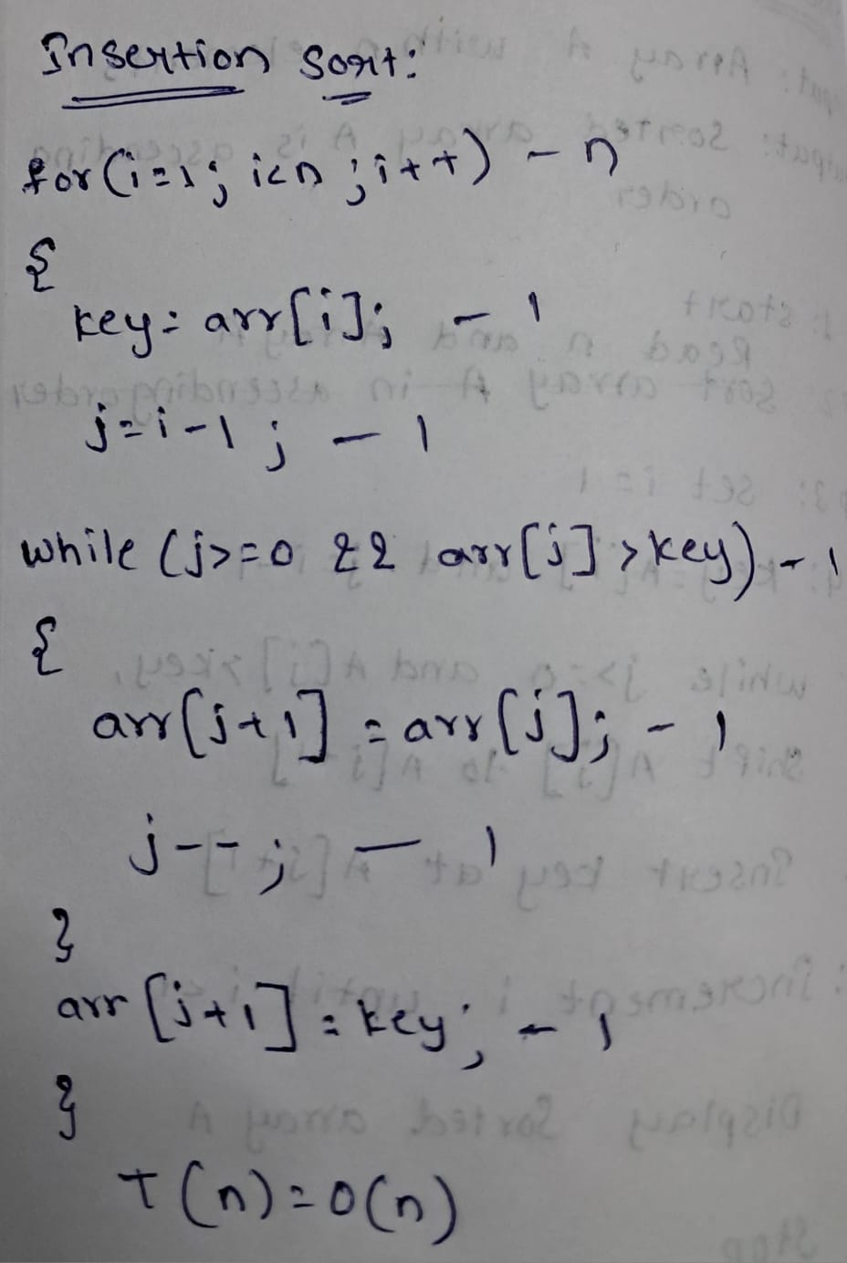

average case:
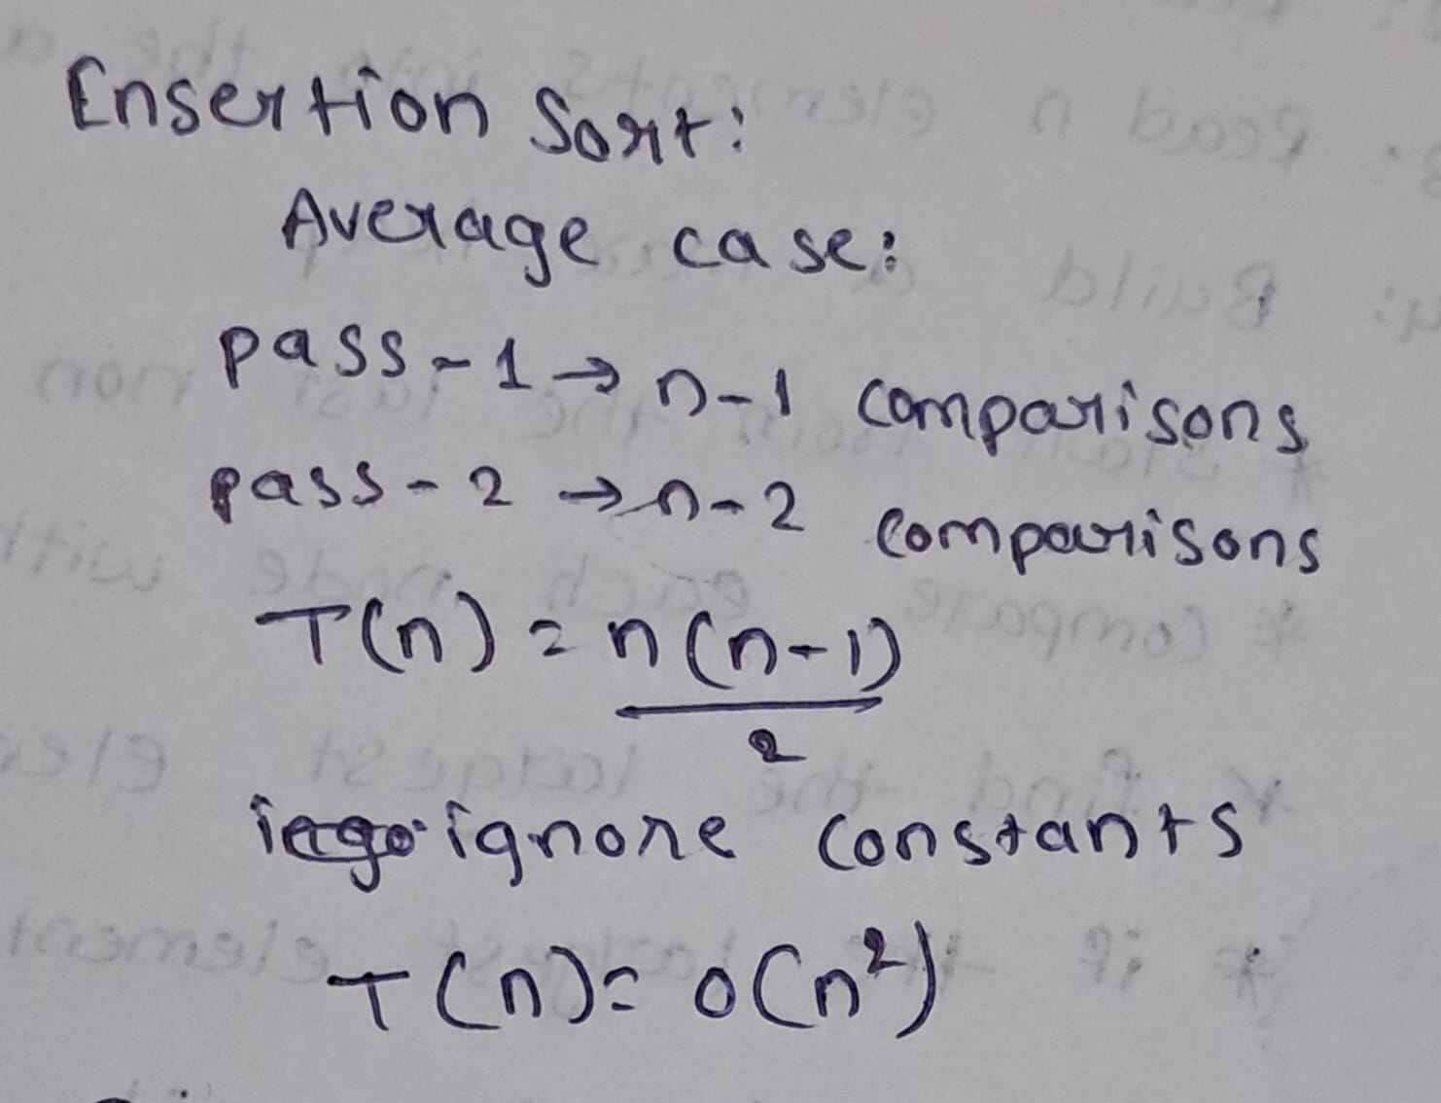
worst case:
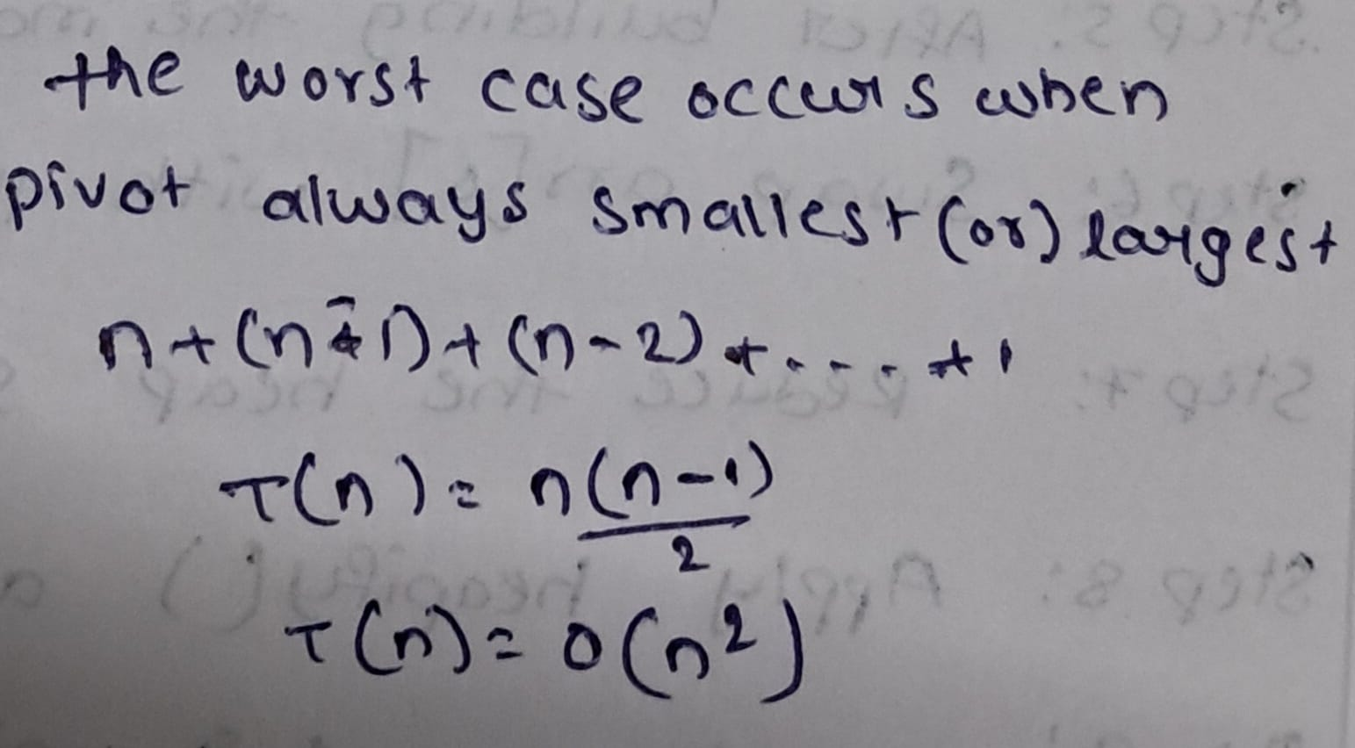
SELECTION SORT:
ALGORTHIM:
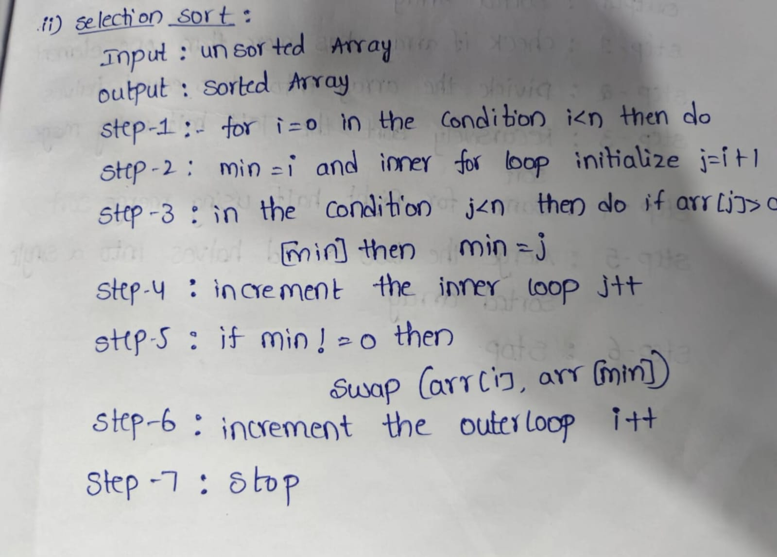
CODE:
#include <iostream>
using namespace std;

class SelectionSort
{
public:
int size, arr[100], i, j, temp;

void arrayinput()
{
cout << "Enter array size: ";
cin >> size;

cout << "Enter array elements: ";
for (i = 0; i < size; i++)
{
cin >> arr[i];
}
}

void printarray()
{
for (i = 0; i < size; i++)
{
cout << arr[i] << " ";
}
cout << endl;
}

void selectionsortlogic()
{
for (i = 0; i < size - 1; i++)
{
int min = i;

for (j = i + 1; j < size; j++)
{
if (arr[j] < arr[min])
{
min = j;
}
}

if (min != i)
{
temp = arr[i];
arr[i] = arr[min];
arr[min] = temp;
}
}
}
};

int main()
{
SelectionSort ss;

ss.arrayinput();

cout << "Before sorting: ";
ss.printarray();

ss.selectionsortlogic();

cout << "After sorting: ";
ss.printarray();

return 0;
}

OUTPUT:

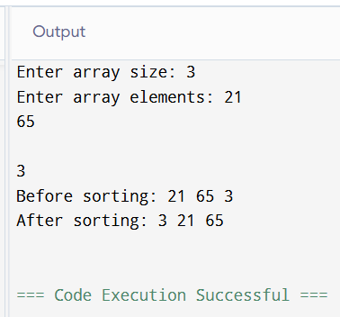

TIME COMPLEXITY:

best case:

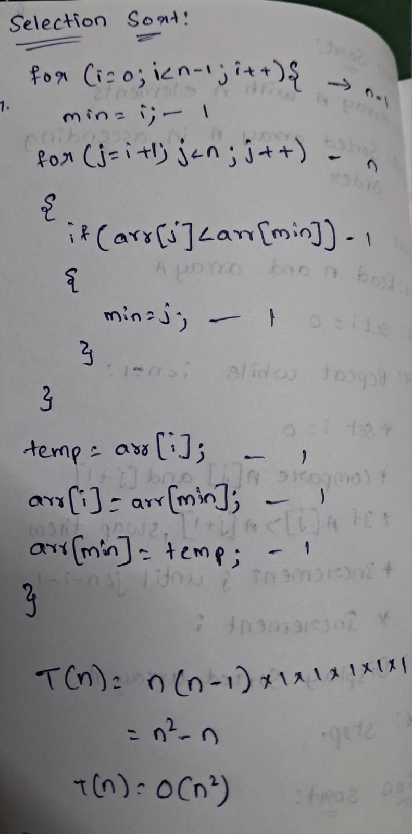

average case:


worst case:


MERGE SORT:

ALGORITHM:

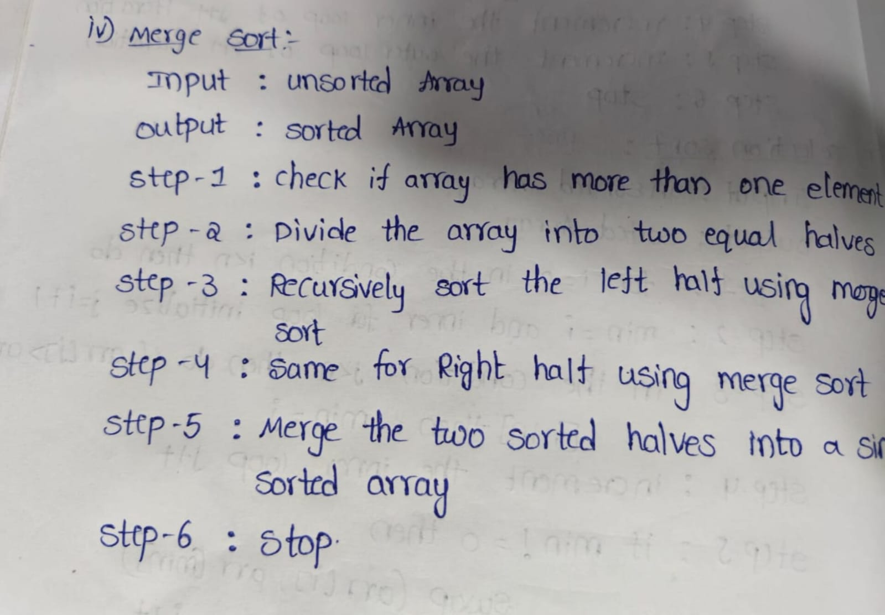

CODE:

#include <iostream>
using namespace std;

class mergesort
{
public:
int size, arr[100], i;

void arrayinput()
{
cout << "Enter array size: ";
cin >> size;
cout << "Enter array elements:\n";
for (i = 0; i < size; i++)
{
cin >> arr[i];
}
}
void printarray()
{
for (i = 0; i < size; i++)
{
cout << arr[i] << " ";
}
cout << endl;
}

void merge(int low, int mid, int high)
{
int temp[100];
int i = low, j = mid + 1, k = low;

while (i <= mid && j <= high)
{
if (arr[i] <= arr[j])
{
temp[k] = arr[i];
i++;
}
else
{
temp[k] = arr[j];
j++;
}
k++;
}

while (i <= mid)
{
temp[k] = arr[i];
i++;
k++;
}

while (j <= high)
{
temp[k] = arr[j];
j++;
k++;
}

for (i = low; i <= high; i++)
{
arr[i] = temp[i];
}
}

void mergelogic(int low, int high)
{
if (low < high)
{
int mid = (low + high) / 2;

mergelogic(low, mid);
mergelogic(mid + 1, high);

merge(low, mid, high);
}
}
};

int main()
{
mergesort ms;

ms.arrayinput();

cout << "Before sorting: ";
ms.printarray();

ms.mergelogic(0, ms.size - 1);

cout << "After sorting: ";
ms.printarray();

return 0;
}

OUTPUT:

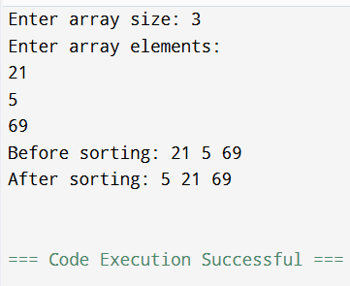

TIME COMPLEXITY:

best case,average case and worst case

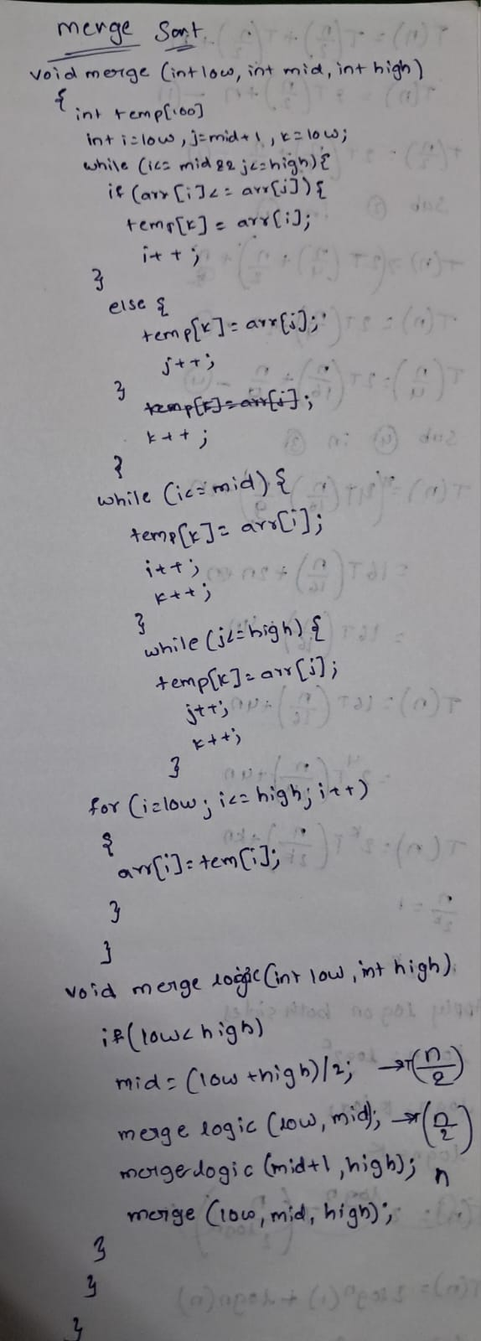
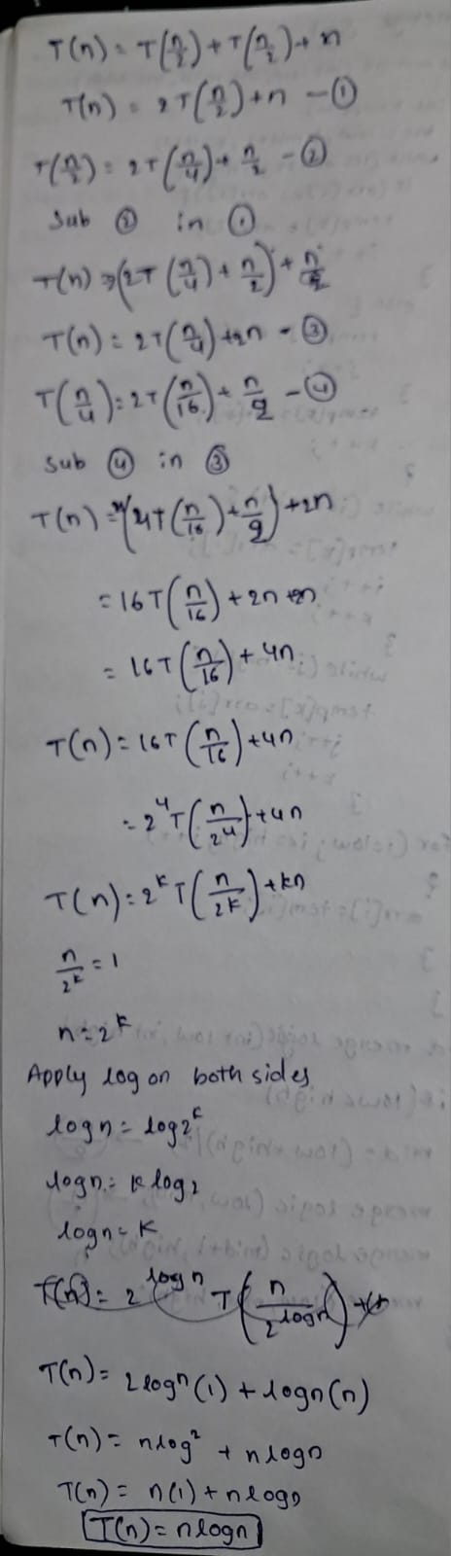

QUICK SORT:

ALGORITHM:

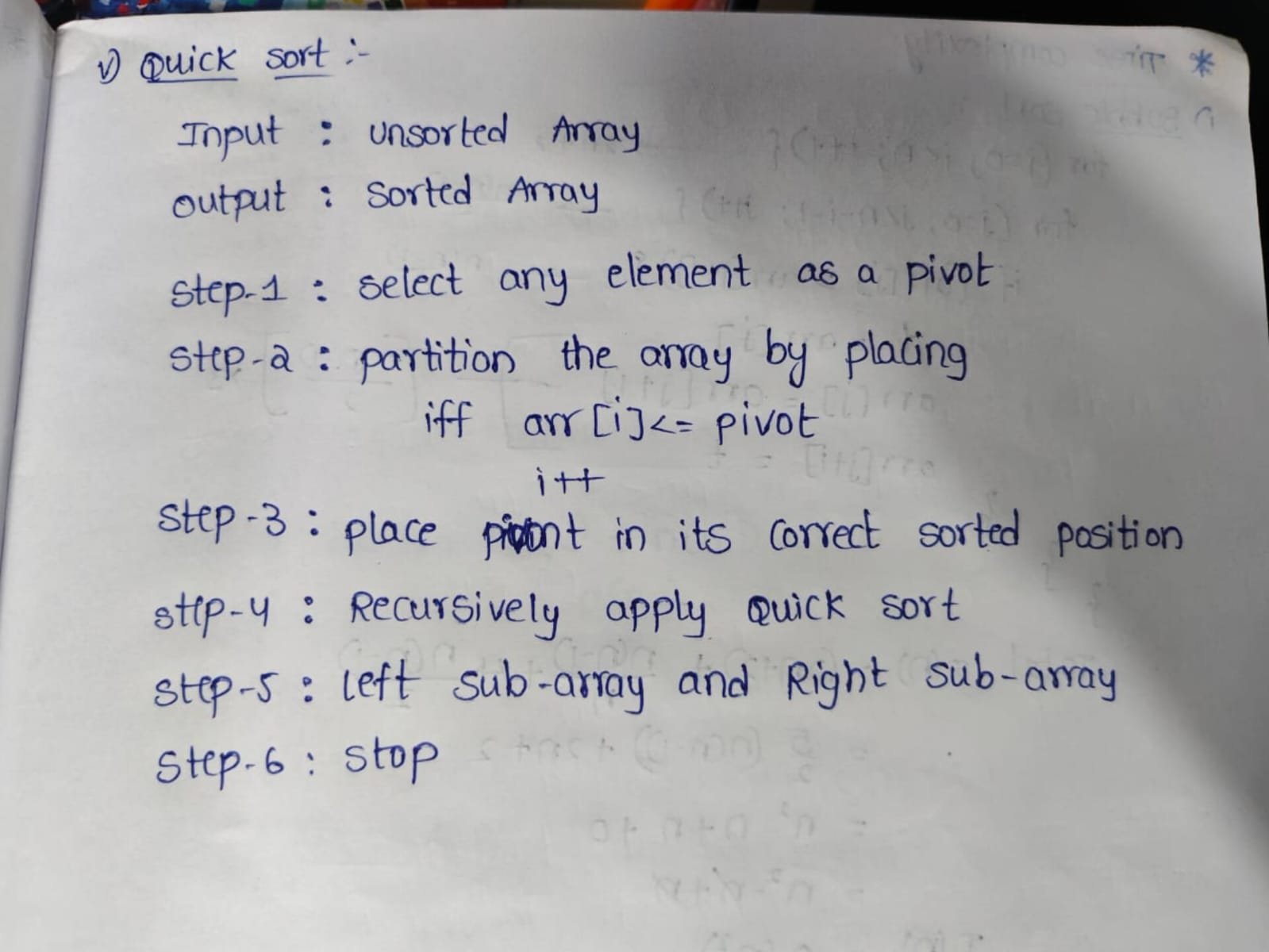

CODE:

#include <iostream>
#include <utility>
using namespace std;

class QuickSort
{
public:
int size, arr[100];

void arrayinput()
{
cout << "Enter array size: ";
cin >> size;
cout << "Enter array elements: ";
for (int i = 0; i < size; i++)
{
cin >> arr[i];
}
}

void printarray()
{
for (int i = 0; i < size; i++)
{
cout << arr[i] << " ";
}
cout << endl;
}

int partition(int lb, int ub)
{
int pivot = arr[lb];
int start = lb;
int end = ub;

while (start < end)
{
while (start <= ub && arr[start] <= pivot)
start++;

while (arr[end] > pivot)
end--;

if (start < end)
swap(arr[start], arr[end]);
}

swap(arr[lb], arr[end]);
return end;
}

void quicksortlogic(int lb, int ub)
{
if (lb < ub)
{
int loc = partition(lb, ub);
quicksortlogic(lb, loc - 1);
quicksortlogic(loc + 1, ub);
}
}

void sort()
{
quicksortlogic(0, size - 1);
}
};

int main()
{
QuickSort qs;

qs.arrayinput();

cout << "Before sorting: ";
qs.printarray();

qs.sort();

cout << "After sorting: ";
qs.printarray();

return 0;
}

OUTPUT:

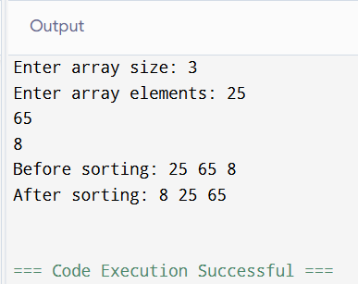

TIME COMPLEXITY:

Best case:

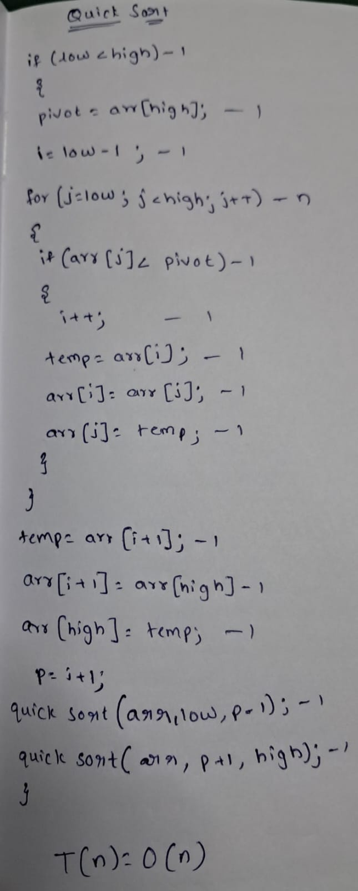

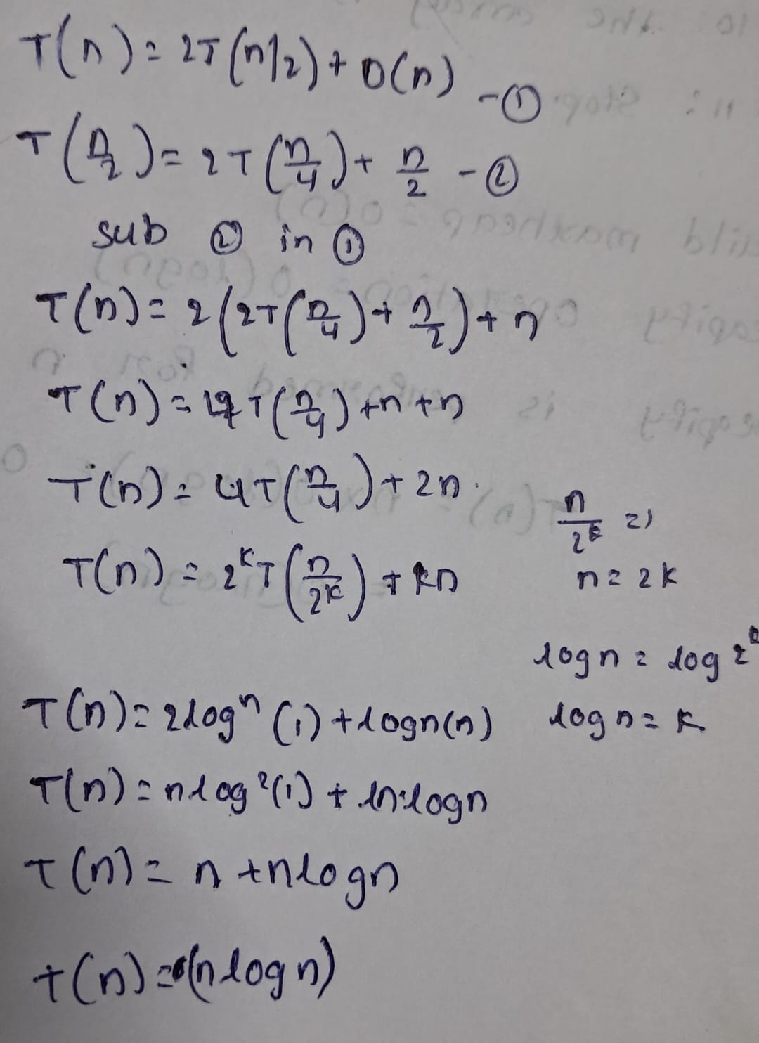

average case:



worst case:


CONCLUSION:
Hence, By Implementing and analysing of sorting algorithms. Bubble sort, Selection sort, Insertion sort, Merge sort and Quicksort.
The time complexity plays an important role in the logical part of the program. And the Programs are successfully executed.

